

*Mert Pinar*

*MSc. Business Intelligence and Analytics*

*W1642104*

**Designing a tool for early diagnosis for dementia from neuroimaging data using machine learning**

# Abstract

# Acknowledgment

Table of Contents

Abstract 1

Acknowledgment 2

List of Figures 4

List of Tables 4

List of Equations 4

Abbreviations 5

Introduction 6

1. Dementia 6

a. Epidemiology 6

b. Alzheimer’s disease (AD) 7

2. Image Analysis in Diagnosis of Dementia 9

Methods 12

1. Data Processing 12

a. Application of Big Data Techniques 12

2. Image Processing 13

a. Spherical Brain Mapping 13

b. Brain extraction using FMRIB Software Library (FSL) 14

3. Machine Learning Techniques 15

a. Unsupervised Learning (Clustering) 16

b. Support Vector Machine (SVM) 16

c. Decision Tree 17

Results 18

1. Characteristics of Study Participants 18

2. Analysis of Image Processing 18

a. Spherical Brain Mapping 18

b. Analysis of Brain Extraction Model using FSL-BET and FAST 19

c. Analysis of Support Vector Machines 23

d. Results of Decision Tree 28

e. Results of Unsupervised Learning 30

Discussion 32

Conclusion 34

References 35

# List of Figures

**Figure 1: Difference of the changes between the biomarkers during the progression of Alzheimer’s disease.** 9

**Figure 2: Computation of the mapping vector, v.** 13

**Figure 4**: Image of the mask overlaid on the original image 19

**Figure 5:** Barchart of the output of the NBClust function. 28

**Figure 6:** Visualization of how kmeans split the whole dataset into two clusters. 29

# List of Tables

**Table 1.** Demographic information of images used in the study 17

# List of Equations

**Equation 1: Calculation of brain surface.** 14

**Equation 2: Calculation of brain thickness.** 14

**Equation 3: Representation of SVM.** 16

# Abbreviations

|  |  |
| --- | --- |
| AD | Alzheimer’s Disease |
| **ADNI** | Alzheimer’s Disease Neuroimaging Initiative |
| **APOE** | Apolipoprotein E |
| **Aß** | Amyloid ß |
| **CSF** | Cerebrospinal Fluid |
| **ETL** | Extract, Transform and Load |
| **HC** | Healthy Controls |
| **MCI** | Mild Cognitive Impairment |
| **SBM** | Spherical Brain Mapping |
| **SVM** | Support Vector Machine |

# Introduction

## Dementia

Dementia is a cumulative term for a variety of changes that affect brain physiology, those effect person’s daily activities by causing long term and often progressive diminishing on capability of thinking and remembering (Burns and Iliffe, 2009). In addition to these symptoms, there are emotional disturbances, difficulty on speech and motivational decrease (Burns and Iliffe, 2009). For diagnosis there should be distortions on person’s mental functioning and one expected to have a significant decrease than projected due to aging (Budson et al., 2016). Until late 19th century, dementia had a vague description and a simple clinical concept, that at that time it can described as anyone who had lost their ability to think and reason (Berrios, 1987). Moreover, the term was also used for defining the mental illnesses and incapacities those can be reversible by right treatment (Berrios, 1987). In several studies, it is stated that there is no known cure for dementia (Iliffe et al., 2009). However, there are some medications that could help people where disease is at mild to moderate stage, but overall expectation of positive feedback is unlikely (Comission de la transparence, 2012). Despite the challenges of diagnosis and treatment of dementia, Zaccai et al. (2006) are believed that population-focused experiments can break the existing walls of biological indicators for cognitive and behavioural changes, and can provide further information for clinical and neuropsychological developments (Zaccai et al., 2006).

### Epidemiology

Since the population on the Earth is growing old, dementia has become one of the biggest concerns globally, which causes a significant burden for the people themselves besides their families and social and health care groups (Prince et al., 2014). Estimated population with dementia is 135 million within 2050, and the cost of care calculated as $604 billion globally in 2010 and it is expected to rise around $1 trillion by 2050 (Prince et al., 2014). The majority of dementia patients are diagnosed with Alzheimer’s disease, followed by vascular dementia and Lewy body dementia (Bermejo-Pareja et al., 2008). Out of 10-15 thousand patients, 5-8 thousand of them are suffering from Alzheimer’s disease (Bermejo-Pareja et al., 2008). Another study carried out that 0.4% of world’s total population (26.6 million) is diagnosed by Alzheimer’s in 2006, and with its expanding rate, currency of AD will increase three times and the number of people suffering to be quadrupled by 2050 (Brookmeyer et al., 2007).

### Alzheimer’s disease (AD)

Alzheimer’s disease is a neurodegenerative disorder, which affects multiple brain areas, and demonstrates a progressive disease course with broad range of symptoms changes within the individual patient (Masters et al., 2015a). Disease symptoms are usually spotted in frontal and temporal lobes of the brain tissue, then it spreads to the other areas of the cortex (Masters et al., 2015a). The incidence rate of the disease amongst the population with the age over 65 years old ranges between 10-30% based on gender and ethnicity (Bachman et al., 1993). The disease progresses and spreads exponentially within the brain cells of more than 90% of the patients, which are generally varies between the age of 80-90 years (Masters et al., 2015a). Average duration of the AD is approximately 10 years after diagnosis, yet the initiation of symptoms extends the duration over two decades (Evans et al., 2003).

***Pathophysiology.*** The pathophysiology of the AD can be related the formation of amyloid β (Aβ) plaques and tau fibrils as a result of protein aggregation (Golde et al., 2000, Selkoe, 2001). These accumulation of insoluble plaques in extracellular spaces result the formation of neurofibrillary structure of the brain (Spielmeyer et al. 1922). In addition, disease also has strong genetic connections via increased production of apolipoprotein E (APOE), which is a crucial risk factor for AD that make individuals more susceptible to disease (Fernandez-Miranda et al., 1997). In overall, these changes in the brain physiology result synaptic and neuron loss, and also decrease in the production of neurotransmitters which are the chemical messengers of neural cells (Masters et al., 2015a). The interrupted communications between the brain cells, or complete loss of these cells can cause the condition called brain atrophy, which is also known as “shrinkage” of the brain (Pini et al., 2016).

***Diagnosis, Monitoring and Treatments***. Diagnosing either dementia and Alzheimer’s disease can be difficult due to subject not accepting that he/she forgets at their earlier stages, similarity of symptoms with memory loss that comes with normal ageing process and diversity of other indications as well, for example uncertainty on making decisions and hassle to find the words whilst speaking (Kostopoulou et al., 2008). Diagnosis of AD can be also challenging for physicians, since there is no direct test for diagnosis, and the process contains the interpretation of neurological functions, analysis of MRI scans and cognitive and memory tests, as well as addition of genetic tests in some of the cases (Knopman et al., 2001). On the other hand, co-morbidies such as cerebrovascular disease, and hippocampal sclerosis are very common within the age range of AD patients, which makes diagnosis really complicated (Duncan et al., 2014).

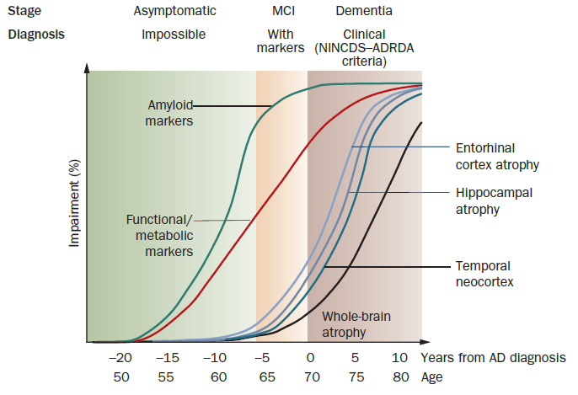

**Figure 1: Difference of the changes between the biomarkers during the progression of Alzheimer’s disease.**

Theoretical model of biological markers in Alzheimer’s disease. x axis indicates the ages of the patients and years before/after their AD diagnosis, and y axis shows the percentage changes of the biological markers whereas lines indicates the biological markers including; Amyloid marker (green), Functional/metabolic markers (red), Entorhinal cortex atrophy (light blue), Hippocampal atrophy (purple), Temporal neocortex (blue) and Whole-brain atrophy (black). On the graph, green layout parts are the stage that there are no symptoms exist whereas, orange part indicates mild cognitive impairment and brown part is where all the samples are diagnosed with Alzheimer’s disease. *Figure is obtained from Frisoni et al. (2010).*

Aβ PET imaging is a technique that uses radioactive analogue of the fluorescent amyloid dye thioflavin-T (Pittsburgh compound B (PiB)), which goes through the blood-brain barrier (BBB), binding Aβ plaques (Mathis et al., 2002). In past ten years, studies with PiB helped people to understand the correlation between Aβ accumulation and cognitive decline, neuro-degeneration and dementia phases of AD (Masters et al., 2015b). The studies showed that accumulation of Aβ starts years before dementia and being followed by cognitive decline and brain atrophy, which makes it an important biomarker for diagnosis for both MCI and AD (Rowe et al., 2013, Villemagne et al., 2013). Use of Aβ marker for diagnosis lead unreliable results and misdiagnoses (%35), that patients with negative Aβ PET scans were misdiagnosed as having Alzheimer’s disease (Salloway et al., 2014).

Measurement of hippocampal volume is another way of determining neuronal counts and understanding more about progression of disease (Shi et al., 2009), as shown in ***Figure 1***. However, Aβ markers are more likely to be effected than structural markers (change in the volume of different brain areas) during the conversion of MCI to mild stages of AD (Sluimer et al., 2008). Hence, it is really important to detect AD in the early stages of disease development to prevent serious potential consequences of the disease.

Studies on early detection of AD is very important interdisciplinary research area, that includes neurobiology, genetics, bioinformatics and computer science cumulatively. There is no specific and direct treatment for AD has applicable, since the death of brain cells cannot be reversed easily and the drugs available can only reduce the symptoms.

## Image Analysis in Diagnosis of Dementia

Besides the ineffective use of biological markers in the diagnosis and monitoring of dementia, the analysis MRI scans by using computational tools with the application of machine learning provides an increasing area of research. Recent studies are suggested promising results on application of machine learning tools to early detection with many different techniques, but all of the studies are lack of validation studies and standardized models to apply as a diagnostic tool. Standardization of the applied models have limitations in the fields of: different sample data sets (participant features, size and groups), analysis and applications of chosen algorithms.

Even though, there are several limitations in the machine learning applications for the early detection of AD, all of the studies that achieved are provided a useful platform for future studies. The accelerating research on AD physiology to detect clinical biomarkers to overcome unmet medical needs can be supported by the machine learning applications which is one of the main motivations for this project. In addition, increasing the understating of stages of early disease with image processing and machine learning can help to interpret more about AD pathophysiology and identification of future drug-candidates.

Objective

The main purpose of this project is to design a platform that can differentiate Alzheimer’s disease, the most common form of dementia, using MRI scans from patients with AD and mild cognitive impairment by comparing the neuro-images of health volunteers.

To this end, the individual objectives can be stated as;

1. Process the MR images by obtaining spherical brain mapping, which followed by extraction of brain with FAST-BET library.
2. Run analysis to obtain brain volume, white and grey matter and cerebrospinal fluid (CSF) for patients with AD, MCI and normal controls.
3. Application of machine learning algorithms to test the sensitivity and specificity of the machine for the diagnosis and clustering of study participants based on physical brain features.

# Methods

## Data Processing

Data was composed of the collection of T1-weighted MR images which were in nii format, gathered from Alzheimer’s disease Neuroimaging Initiative (ADNI)* database. In dataset, there were total of 479 patients and 1314 MR images. 415 of those images were belong to healthy participants, 657 of those images were whom are suffering from MCI and, finally 242 images with patients of AD. The age of study subjects was varying between 55 to 92 years, which the participant demographics are given below in ***Table 1*** in the results section.

*Data used in preparation of this study were obtained from the Alzheimer’s Disease Neuroimaging Initiative (ADNI) database (adni.loni.usc.edu). As such, the investigators within the ADNI contributed to the design and implementation of ADNI and/or provided data but did not participate in analysis or writing of this report. A complete listing of ADNI investigators can be found at:

<http://adni.loni.usc.edu/wp-content/uploads/how_to_apply/ADNI_Acknowledgement_List.pdf>

### Application of Big Data Techniques

After data was obtained from ADNI database, it was stored in a folder size of 90 GB. First approach is to organize the data for smart loops for the image processing part. To this end ***Extract, Transform and Load*** (ETL) approach was used for the images. In this study, two image processing techniques were examined. These two techniques applied different methods to transform images to generate: 1. Arrays of numbers and 2. Values for physical features of the brain as outputs that were ready to use in the following analysis.

For the first approach of the image processing, images were extracted from a pool and transformed into extensive arrays with 10 million elements, then those arrays were stored in a dataset to be loaded by the machine. For the second approach, images were directly transformed into meaningful values; such as brain volume and volume of grey matter, white matter and CSF. After processing the images and obtained the values of physical features of the brain for each patient, the data was stored in a dataset with respective patients’ ID and group. Then these datasets were ready to be used for the machine learning techniques.

## Image Processing

After sorting the data, images should turn into some values those are meaningful for computer, so that machine could relate mathematical formulas by the pattern of the advancing disease. The goal of the image processing part was to convert images to large sized arrays.

### Spherical Brain Mapping

Spherical Brain Mapping (SBM) is a technique that focuses on the spherical coordinates of the brain and convert brain image from 3D to 2D map which first used by Martinez-Murcia et al. (2016). Central point of the MR image set as a reference base point and a mapping vector ($v$) created and populated for each angles covering the brain, as shown in ***Figure 2***. After obtaining Vθ,ϕ, which was covering each voxel of the mapping vector $v$, the mathematical formulas could be applied to calculate certain brain physical features, such as brain surface or thickness of the tissue. Those values then could be applied to measure brain atrophy and relation with white and grey matter ratios.

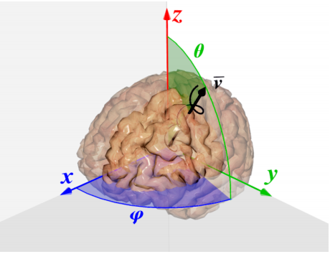

**Figure 2: Computation of the mapping vector, v.**

Illustration of populating the mapping vector $v$ (black) in x, y and z directions in the space, as the angles θ (green) and ϕ (blue) embraces the brain on every angle. That provides a coverage of all points as an output of the model. *The figure is obtained from Martinez-Murcia et al. (2016).*

The first parameter that was calculated is the brain surface. Surface can be calculated as the sum of every last tissue voxel of each Vθ,ϕ. Tissue loss on the surface or worsening on structural model could be measured by using the following formula:

$$v_{surface}= \max_{i}{{(V}_{θ, ϕ}(i)) ADDIN EN.CITE ADDIN EN.CITE.DATA } ∀i∈1,…P$$

**Equation 1: Calculation of brain surface.**

Then, calculation of white and grey matter of the brain tissue was achieved by calculating the thickness of the tissue by differentiating every last point of each vectors from the starting point of their first. Hence the distance between the starting point and the ending point was assessed by using the formula below:

$$v_{thickness}= \max_{i}{{(V}_{θ, ϕ}(i))}- \min_{i}{{(V}_{θ, ϕ}(i))} ∀i∈1,…P$$

**Equation 2: Calculation of brain thickness.**

Results of these calculations were in the form of the value $v$, that mapped for every direction ranging θ and ϕ. These $v$ vectors were divided to $n$ equal parts, hence the layers of the brain could be obtained, which was called layered approach. Then these layers were kept in extensive datasets as samples for Support Vector Machines (SVM).

### Brain extraction using FMRIB Software Library (FSL)

The second approach for the image processing was extracting only the brain tissue from MRI scans, and calculate the volume of white matter, grey matter and volume of the brain as a cumulative value from addition of white matter, grey matter and cerebrospinal fluid (CSF). To extract the relevant information FMRIB (Functional MRI of the Brain) software library which is fslr package in R was used. This package provided functions for plotting and manipulating the images for the following analysis. There were two main functions used from the package which were BET (Brain Extraction Tool) and FAST (FMRIB’s Automated Segmentation Tool).

The obtained dataset from the ADNI database were in the form of NIfTI (Neuroimaging Informatics Technology Initiative), which has the file extension of nii as mentioned in section Data Processing in Methods. ‘nifti’ object was passed into the BET function as the following to extract the brain tissue from the total image includes skull, neck and all the detailed parts of the head:

fslbet(infile = “ADNIDataset$mriAddress[i]”,

outfile = “ADNIDataset$extractedBrain[i]”,

opts = “-B -f 0.1 -v”)

Brain extraction, known as skull stripping, is very crucial step in the following analysis. To this end FSL’s brain extraction tool was used with the parameters recommended in the study of Popescu et al. (2012). BET was run on the T1-weighted MRI with the suggested options of B and f. B is an option for correction to image bias and used to eliminate inhomogeneity between the images, as well as clearance of the neck area. Option f provides a fractional intensity parameter, which ranges between 0 and 1, and determines the brain image’s edge location. This parameter also used to generate brain mask to outline the brain from total image. The v in the list of function options switched on the diagnostic messages, stands for ‘verbose’. After application of this function, the brain masks were obtained and the outputs were used in the FAST function.

FAST was to applied to previously obtained 3D images of extracted brain tissues to differentiate various tissue types; such as grey matter, white matter and CSF. Simultaneously, FAST application also contained biased-field correction algorithms. FAST algorithm used hidden Markov model, and the whole process was fully automated, which ran partial volume and tissue segmentation on input images.

Finally, volume of white matter, grey matter and brain tissue was extracted and the example of one study participant was given in the ***Figure 3***. Output was stored in a dataset for next steps.

## Machine Learning Techniques

In this part, three different methods were applied to achieve multivariable analysis and test and compare the accuracy of the used models. To this end, various supervised and unsupervised learning methods were examined.

### Unsupervised Learning (Clustering)

First step was to determine appropriate machine learning technique to use in this study, which was clustering and visualizing the data based on obtained brain features, as described previously. To this end, group column was deleted from the initial dataset, then NbClust function was run to obtain the number of clusters according to various algorithms as the following:

clusterSuggestion = NbClust(dataset, max.nc = 5, min.nc=2,

method = “kmeans”)

The goal was to cluster the rows of the dataset based on the variables on selected columns, such as volume of brain tissue, and allow available indices to detect and spot the ideal amount of clusters in the original data. In this study, the amount of clusters set between 2 and 5. As a parameter k-means was chosen for the function method, since it is the one of the most popular partitioning algorithms and was used in numerous packages in R, such as cclust, clustTool, clue, among others.

### Support Vector Machine (SVM)

Since there were 3 classes of study participants; Normal Control, Alzheimer’s Disease and Mild Cognitive Impairment, separation of classes was needed for this method to use SVM. Two types of SVMs were tested in this study, and both were developed as ***Leave One out Cross Validated SVMs***, those were linear and polynomial. For both linear and polynomial kernel, C hyper parameter was 1 as default. For polynomial kernel degree of function was 3, scale was 0.1 and offset was 1. Number of support vectors for polynomial model was 262, whereas it was 261 for the linear model. Since SVM is a margin binary classifier which’s function can be represented as below;

$$y\left(x\right)= \sum_{n=1}^{N}{w_{n}.t_{n}. k\left(x,x_{n}\right)+b}$$

**Equation 3: Algebraic representation of SVM.**

Where N is the number of the subjects in the dataset, $w_{i}$ is the weight of the value which was assigned by the SVM during the training step and $k\left(x,x_{n}\right)$ is the kernel function that shapes the separating hyper-plane, and b is a bias. The function $y\left(x\right)$ is the predicted label for the subject, which is disease group in this study. Caret library was used for SVM training and classification in R. In total, 200 subjects were used to train the machine and 92 of them then used for testing.

### Decision Tree

The data classification was also assessed by application of decision tree algorithm, which used the brain features to classify the groups. To this end, 200 subjects were used to training the machine and 92 of those used for testing the accuracy of the method. Caret library was used and J48 (C4.5) decision tree algorithm was applied. The chosen control method was ***Leave One out Cross Validation.*** The implementation can be stated as below:

decisionTree = train(form, data = ADNIDataset, method = "J48",

trControl = trainControl(method = "LOOCV"))

## Data Analysis

Data analysis were achieved by R Studio, and the statistical test were applied where applicable. For comparison of AD, MCI and NC within each other, mean and standard deviation of each group calculated and One-way ANOVA and multiple comparisons were applied. The appropriate post-hoc test also applied if needed, where the significance rate was obtained as 0.05.

# Results

## Characteristics of Study Participants

Study participants were separated into groups of healthy volunteers (Normal Control, NC), mild cognitive impairment (MCI) and Alzheimer’s disease (AD) by using the reduced dataset. The information of patient demographics are shown in the ***Table 1***, below.

**Table 1:** Demographic information of images used in the study.

|  |  |  |  |
| --- | --- | --- | --- |
|  | NC | MCI | AD |
| Number of images | 96 | 151 | 45 |
| Gender (Female %) | 50% | 40.4% | 64.4% |
| Age (Mean) | 77.9 | 76.3 | 77.6 |
| Age (Range) | 63 - 90 | 57 - 91 | 70 - 87 |

In the reduced data set that was used in the analysis of this study, total of 96 NC, 151 MCI and 45 AD images were used. The total of 47.2% of the subjects were females, who have in total of 138 images out of 292. Amongst patients with MCI, 40.4% of them were female and this ratio is higher in AD patients as 64.4%. The average age of NC was 77.9 with range of 63 to 90, for MCI 76.3 with range of 57 to 91. Similarly, mean of the age of AD patients was 77.6 varying between 70 and 87.

## Analysis of Image Processing

### Spherical Brain Mapping

With spherical brain mapping approach, T1 images were assessed as explained in section ….., and obtained as a large-sized array. That process took about 3 minutes for each image and output of the function was an array consists of 10.9 million elements with the size of 80 MB. The summary of the output is given below:

----------------------------------------

NIfTI-1 format

Type : nifti

Data Type : 16 (FLOAT32)

Bits per Pixel : 32

Slice Code : 0 (Unknown)

Intent Code : 0 (None)

Qform Code : 1 (Scanner_Anat)

Sform Code : 0 (Unknown)

Dimension : 256 x 256 x 166

Pixel Dimension : 0.95 x 0.94 x 1.2

Voxel Units : mm

Time Units : Unknown

----------------------------------------

This method cannot be used for the following analysis, which the limitations and the reasons discussed in the following sections.

### Analysis of Brain Extraction Model using FSL-BET and FAST

Similar to the spherical brain mapping, fslbet function also process the NIfTI image formats. First step was to load the image to FSL which took approximately a minute, then bet function was used to extract the brain out of the skull, that process lasted around 3 minutes. As an output BET function returns a *Large nifti* file which is 45 MB, which is same as the raw image. The output was a brain mask image that covers the brain but extracts the skull **(*Figure 3*).** This mask image was binary, where 0 indicated outside of the brain while 1 indicated the inside. Then these masks were used in FAST function for each image, separately.

Then FAST function was called with three classes chosen, those classes were white matter, grey matter and CSF. For this project volume of white and grey matter was used, separately. Additional to these, brain volume also calculated as a cumulative result of WM, GM and CSF. The output was binary segmentation (hard segmentation) of one image per class. Any additional correction option for input wasn’t selected and no information of estimated bias field was used, since the BET function includes correction operations itself.



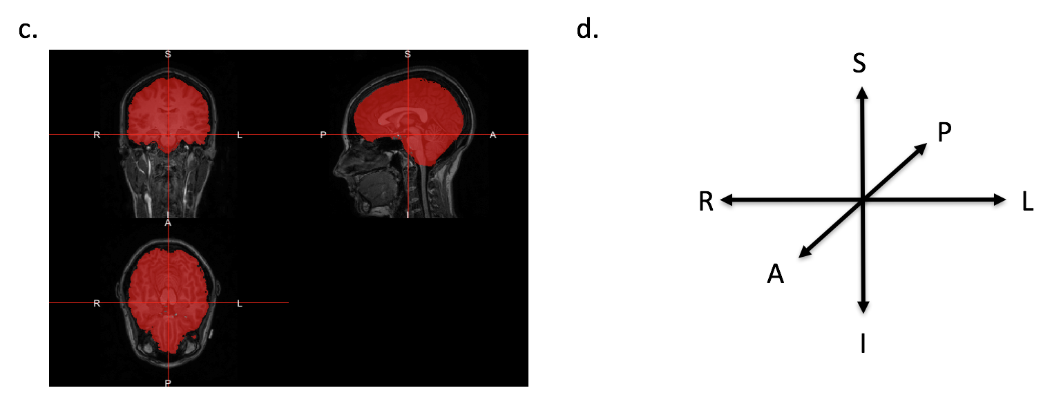

**Figure 3**: **Application of FSL – BET to MRI scans.**

Representative data from a single subject (n=1). (a) The raw data of the brain images that obtained from ADNI database, (b) Brain extraction was obtained after application of BET function, that eliminates the unnecessary parts, (c) The obtained masks (red) for the extracted brain tissue, (d) Directions of MRI scan orientation. *A: anterior, I: Inferior, L: Left, P: Posterior, R: Right, S: Superior.*

The brain volume (cm3), ratio of WM and GM to total brain volume were then compared within each group, individually ***(Figure 4).*** Brain volume of AD patients were obtained lower than both MCI and NC, but only the difference between AD and MCI was statistically significant (One-way ANOVA and Multiple Comparisons with Dunnett’s Contrasts, p= 0.0379). Comparisons of grey matter ratio were also assessed, and the amount of grey matter in AD patient’s brain was calculated lower than MCI and NC but the differences between the groups were not statistically significant (One-way ANOVA, p=0.24). Similar results were also obtained for white matter comparisons (One-way ANOVA, p=0.66).

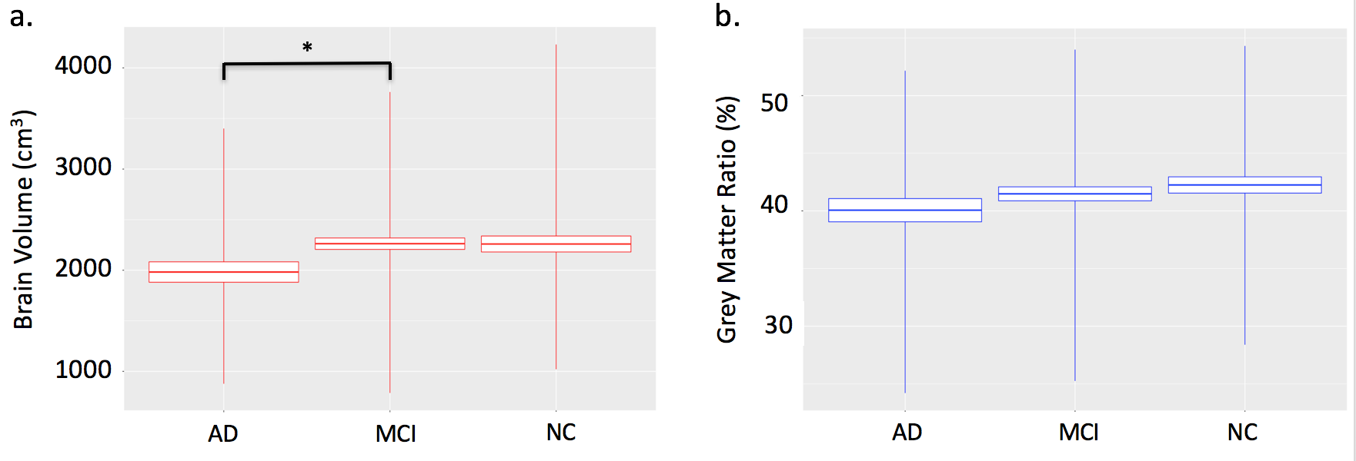

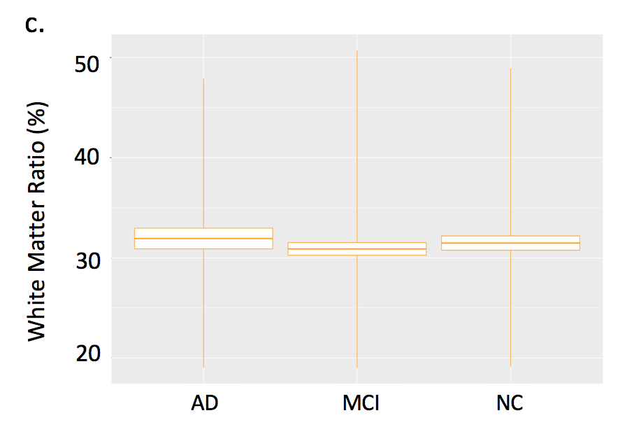

**Figure 4: Analysis of brain features in AD, MCI and NC.**

Brain volume (a), grey matter ratio (b) and white matter ratio (c) in patients with Alzheimer’s disease (AD), mild cognitive impairment (MCI) and normal controls (NC). *p<0.05 One-way ANOVA with Dunnett’s Multiple Comparison Test.

In the ***Figure 5***, the correlation between brain volume with white matter and grey matter were also assessed for each group, separately. For all of the study groups, grey matter ratio was increasing with increase in the brain volume, while white matter ratio decreasing. However, these variations in the WM and GM were not linearly correlated with the brain volume as R-squared values are calculated and given in the **Table 2**.

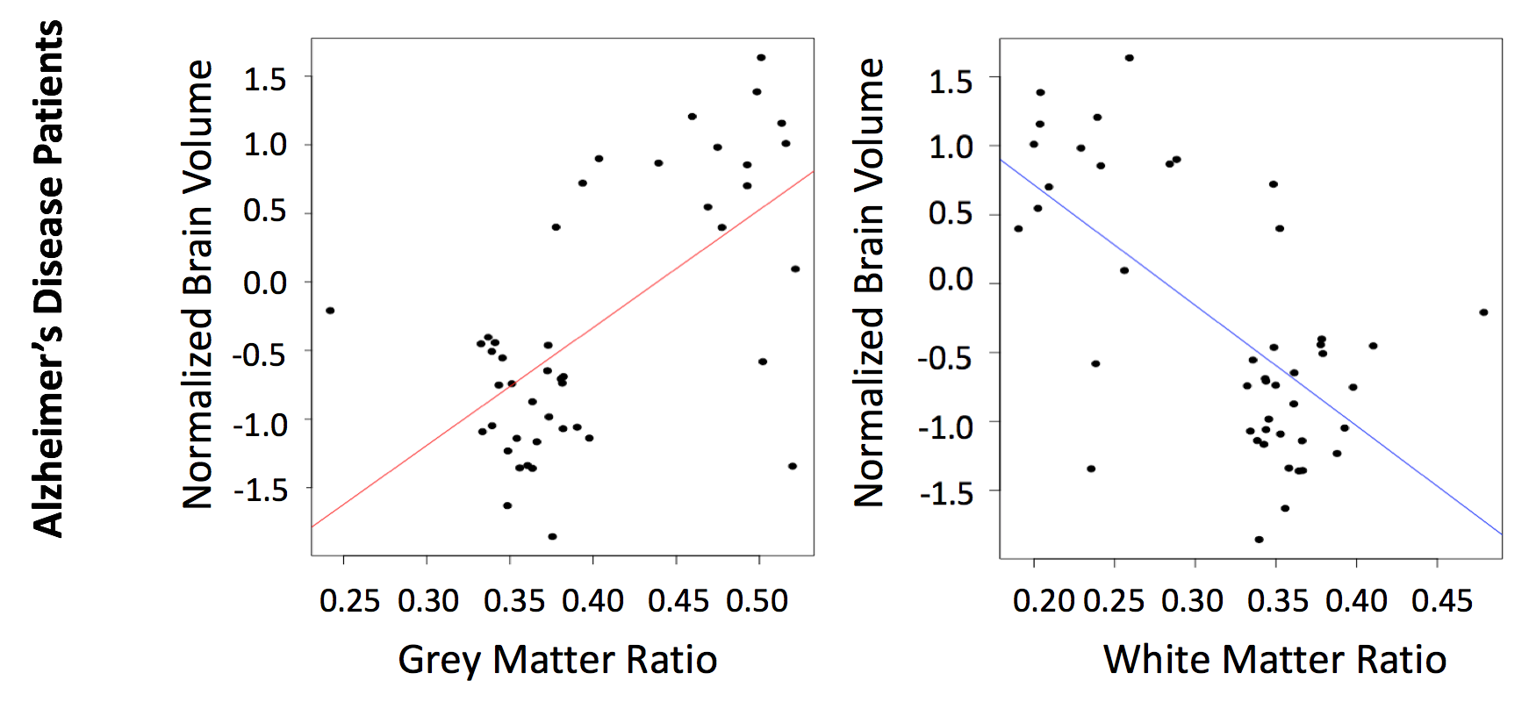

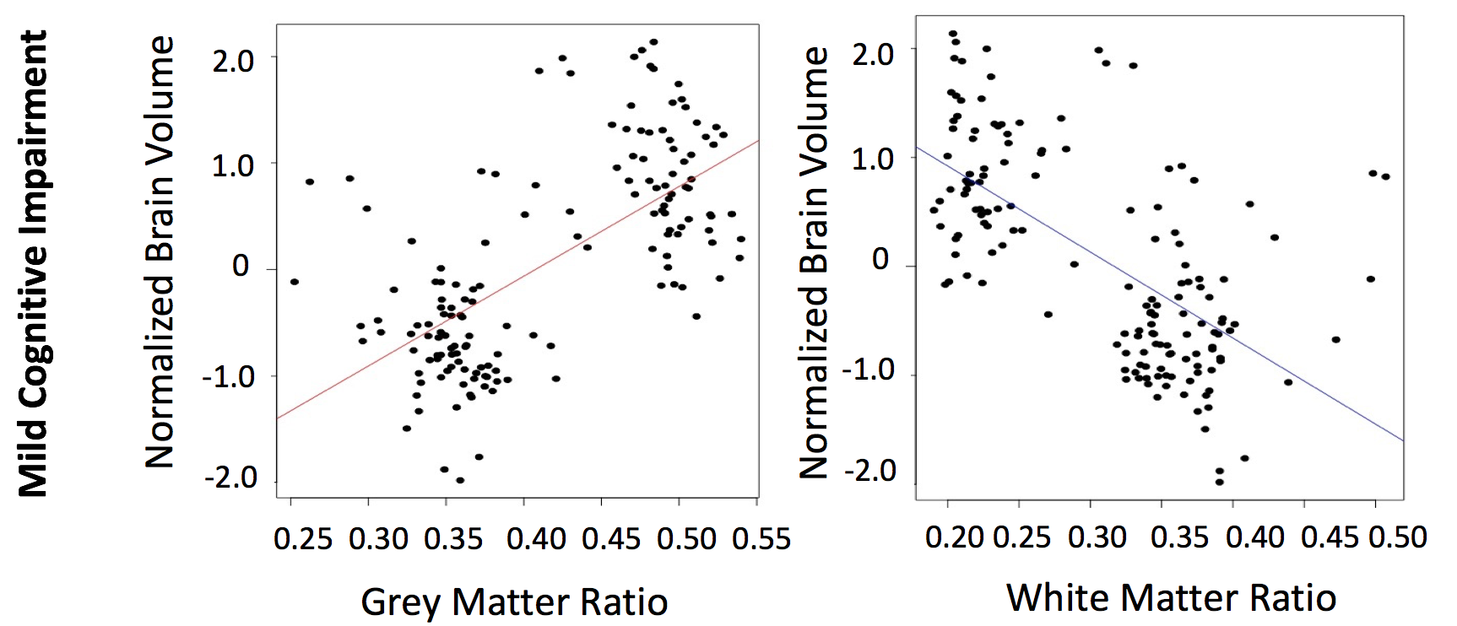

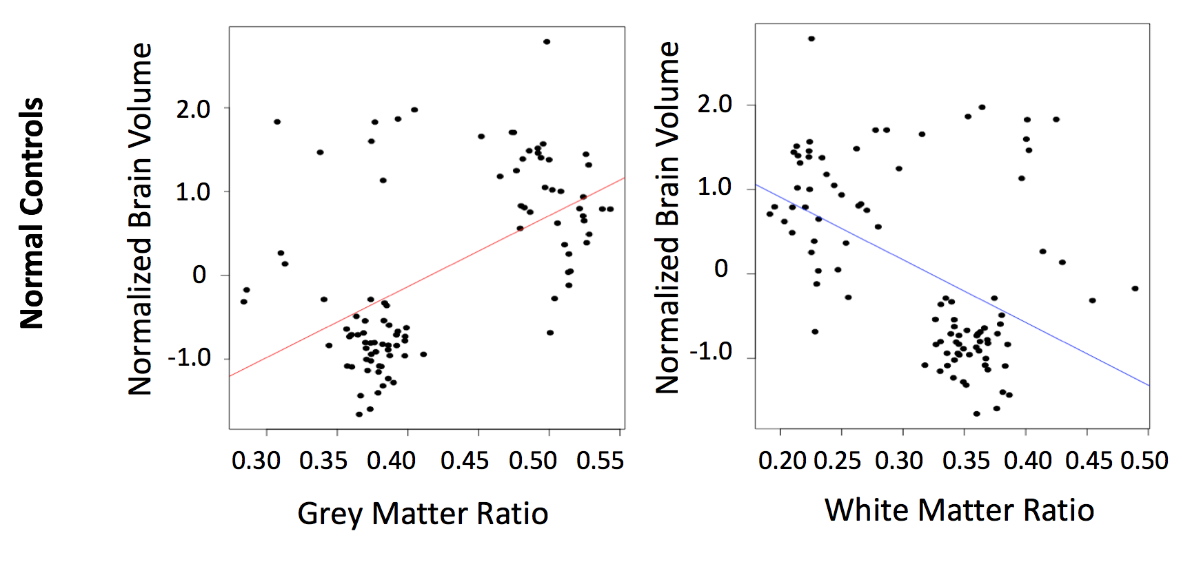

**Figure 5: Analysis of correlation of normalized brain volume with grey matter and white matter for AD, MCI and NC.**

Scatter plots of normalized brain volume and grey matter and white matter ratio, respectively. Each dots indicate single study participant for AD (n= 45), MCI (n= 151) and NC (n= 96). Correlation was calculated based on linearity of line which was indicated by R-square.

**Table 2:** Correlation between normalized brain volume and grey matter and white matter by diagnostic category. AD: Alzheimer’s Disease, MCI: Mild cognitive impairment, NC: Normal control.

|  |  |  |
| --- | --- | --- |
|  | Brain Volume and Grey Matter | Brain Volume and White Matter |
| R-square | R-square |
| AD | 0.387 | 0.418 |
| MCI | 0.429 | 0.406 |
| NC | 0.428 | 0.234 |

### Analysis of Support Vector Machines

In this project 4 different Support Vector Machines were created and every model were used Leave-One-Out cross validation as resampling. First of them was with the linear kernel and used white matter ratio, grey matter ratio and the total volume of the brain as the formula. Output of the training model was given below;

Support Vector Machines with Linear Kernel

292 samples

3 predictor

3 classes: 'AD', 'CN', 'MCI'

No pre-processing

Resampling: Leave-One-Out Cross-Validation

Summary of sample sizes: 291, 291, 291, 291, 291, 291, ...

Resampling results:

Accuracy Kappa

0.5171233 0

Tuning parameter 'C' was held constant at a value of 1

Model was tested with the last 90 elements of the total dataset. Accuracy of the machine was observed as 60%, but it diagnosed every image with mild cognitive impairment. Confusion matrix of the output was given below;

Confusion Matrix and Statistics

Reference

Prediction AD CN MCI

AD 0 0 0

CN 0 0 0

MCI 8 28 56

Overall Statistics

Accuracy : 0.6087

95% CI : (0.5014, 0.7088)

No Information Rate : 0.6087

P-Value [Acc > NIR] : 0.5455

Kappa : 0

Mcnemar's Test P-Value : NA

Statistics by Class:

Class: AD Class: CN Class: MCI

Sensitivity 0.00000 0.0000 1.0000

Specificity 1.00000 1.0000 0.0000

Pos Pred Value NaN NaN 0.6087

Neg Pred Value 0.91304 0.6957 NaN

Prevalence 0.08696 0.3043 0.6087

Detection Rate 0.00000 0.0000 0.6087

Detection Prevalence 0.00000 0.0000 1.0000

Balanced Accuracy 0.50000 0.5000 0.5000

To test if the predictor amount decreases, will the machine be more accurate. For that since Alzheimer’s disease can be basically explained as shrinkage of the brain, only changes on the volume of the brain was taken as an input to the machine.

Support Vector Machines with Linear Kernel

292 samples

1 predictor

3 classes: 'AD', 'CN', 'MCI'

No pre-processing

Resampling: Leave-One-Out Cross-Validation

Summary of sample sizes: 291, 291, 291, 291, 291, 291, ...

Resampling results:

Accuracy Kappa

0.5171233 0

Tuning parameter 'C' was held constant at a value of 1

Then model was tested with the last 90 objects in the dataset. Accuracy was exactly same as the machine with the three predictors, and this machine also diagnosed every image as mild cognitive impairment. Confusion matrix of the output of the machine is given below;

Confusion Matrix and Statistics

Reference

Prediction AD CN MCI

AD 0 0 0

CN 0 0 0

MCI 8 28 56

Overall Statistics

Accuracy : 0.6087

95% CI : (0.5014, 0.7088)

No Information Rate : 0.6087

P-Value [Acc > NIR] : 0.5455

Kappa : 0

Mcnemar's Test P-Value : NA

Statistics by Class:

Class: AD Class: CN Class: MCI

Sensitivity 0.00000 0.0000 1.0000

Specificity 1.00000 1.0000 0.0000

Pos Pred Value NaN NaN 0.6087

Neg Pred Value 0.91304 0.6957 NaN

Prevalence 0.08696 0.3043 0.6087

Detection Rate 0.00000 0.0000 0.6087

Detection Prevalence 0.00000 0.0000 1.0000

Balanced Accuracy 0.50000 0.5000 0.5000

Then different built machines were tried to increase the accuracy of the models. Instead of tuning the linear kernel support vector machine, support vector machine with polynomial kernel and let the model to choose the optimal degree, scale and the C value. First machine was given the formula with white matter and grey matter ratio and brain volume.

Support Vector Machines with Polynomial Kernel

292 samples

3 predictor

3 classes: 'AD', 'CN', 'MCI'

No pre-processing

Resampling: Leave-One-Out Cross-Validation

Summary of sample sizes: 291, 291, 291, 291, 291, 291, ...

Resampling results across tuning parameters:

degree scale C Accuracy Kappa

1 0.001 0.25 0.5171233 0.00000000

1 0.001 0.50 0.5171233 0.00000000

1 0.001 1.00 0.5171233 0.00000000

1 0.010 0.25 0.5171233 0.00000000

1 0.010 0.50 0.5171233 0.00000000

1 0.010 1.00 0.5171233 0.00000000

1 0.100 0.25 0.5171233 0.00000000

1 0.100 0.50 0.5171233 0.00000000

1 0.100 1.00 0.5171233 0.00000000

2 0.001 0.25 0.5171233 0.00000000

2 0.001 0.50 0.5171233 0.00000000

2 0.001 1.00 0.5171233 0.00000000

2 0.010 0.25 0.5171233 0.00000000

2 0.010 0.50 0.5171233 0.00000000

2 0.010 1.00 0.5171233 0.00000000

2 0.100 0.25 0.5171233 0.00000000

2 0.100 0.50 0.5171233 0.00000000

2 0.100 1.00 0.5171233 0.00000000

3 0.001 0.25 0.5171233 0.00000000

3 0.001 0.50 0.5171233 0.00000000

3 0.001 1.00 0.5171233 0.00000000

3 0.010 0.25 0.5171233 0.00000000

3 0.010 0.50 0.5171233 0.00000000

3 0.010 1.00 0.5171233 0.00000000

3 0.100 0.25 0.5171233 0.00000000

3 0.100 0.50 0.5068493 -0.01720009

3 0.100 1.00 0.5205479 0.03040653

Accuracy was used to select the optimal model using the largest value.

The final values used for the model were degree = 3, scale = 0.1 and C = 1.

It selected degree value as 3, scale as 0.1 and C as 1 for a more accurate model, with accuracy of 52%. Model was tested with the same 90 elements those were used to test the other models.

Confusion Matrix and Statistics

Reference

Prediction AD CN MCI

AD 0 0 0

CN 1 4 1

MCI 7 24 55

Overall Statistics

Accuracy : 0.6413

95% CI : (0.5346, 0.7387)

No Information Rate : 0.6087

P-Value [Acc > NIR] : 0.2987

Kappa : 0.1276

Mcnemar's Test P-Value : 2.073e-06

Statistics by Class:

Class: AD Class: CN Class: MCI

Sensitivity 0.00000 0.14286 0.9821

Specificity 1.00000 0.96875 0.1389

Pos Pred Value NaN 0.66667 0.6395

Neg Pred Value 0.91304 0.72093 0.8333

Prevalence 0.08696 0.30435 0.6087

Detection Rate 0.00000 0.04348 0.5978

Detection Prevalence 0.00000 0.06522 0.9348

Balanced Accuracy 0.50000 0.55580 0.5605

This model’s accuracy is slightly higher than linear kernel model with accuracy of 64% and machine was diagnosing most of the images as mild cognitive impairment. Model was tested with one predictor, as done the same for the linear kernel-ed model. Polynomial kernel model was trained with one predictor. Machine had chosen degree as 1 with scale of 0.001 and C value 0.25 to maximize the accuracy of the model, but the output was not different from the output of the linear kernel model with the same formula, i.e using brain volume to train the model. Machine acted same as it did when it was working on linear kernel as it diagnosed every image as mild cognitive impairment. Confusion matrix for the model was given below.

Confusion Matrix and Statistics

Reference

Prediction AD CN MCI

AD 0 0 0

CN 0 0 0

MCI 8 28 56

Overall Statistics

Accuracy : 0.6087

95% CI : (0.5014, 0.7088)

No Information Rate : 0.6087

P-Value [Acc > NIR] : 0.5455

Kappa : 0

Mcnemar's Test P-Value : NA

Statistics by Class:

Class: AD Class: CN Class: MCI

Sensitivity 0.00000 0.0000 1.0000

Specificity 1.00000 1.0000 0.0000

Pos Pred Value NaN NaN 0.6087

Neg Pred Value 0.91304 0.6957 NaN

Prevalence 0.08696 0.3043 0.6087

Detection Rate 0.00000 0.0000 0.6087

Detection Prevalence 0.00000 0.0000 1.0000

Balanced Accuracy 0.50000 0.5000 0.5000

### Results of Decision Tree

For decision tree, we let the algorithm to choose its own C and M values. Tree was tested with the whole dataset and as a result of training it had decided to determine C as 0.5 and M as 2 and built the model according to those values. Leave-one-out resampling method was used, and the formula was $Group \sim White Matter Ratio+Grey Matter Ratio+Brain Volume$. 3 predictors were given to the model, and the output was one of three classes i.e Alzheimer’s disease, normal control and mild cognitive impairment.

C4.5-like Trees

292 samples

3 predictor

3 classes: 'AD', 'CN', 'MCI'

No pre-processing

Resampling: Leave-One-Out Cross-Validation

Summary of sample sizes: 291, 291, 291, 291, 291, 291, ...

Resampling results across tuning parameters:

C M Accuracy Kappa

0.010 1 0.4212329 -0.1293999

0.010 2 0.4349315 -0.1069500

0.010 3 0.4349315 -0.1069500

0.255 1 0.5479452 0.1939437

0.255 2 0.5650685 0.2296635

0.255 3 0.5616438 0.2176006

0.500 1 0.5479452 0.1939437

0.500 2 0.5684932 0.2340426

0.500 3 0.5616438 0.2176006

Accuracy was used to select the optimal model using the largest value.

The final values used for the model were C = 0.5 and M = 2.

Then the model was tested with the last 90 elements of the dataset. It had the accuracy of 70%. Decision tree it generated and the confusion matrix can be found below;

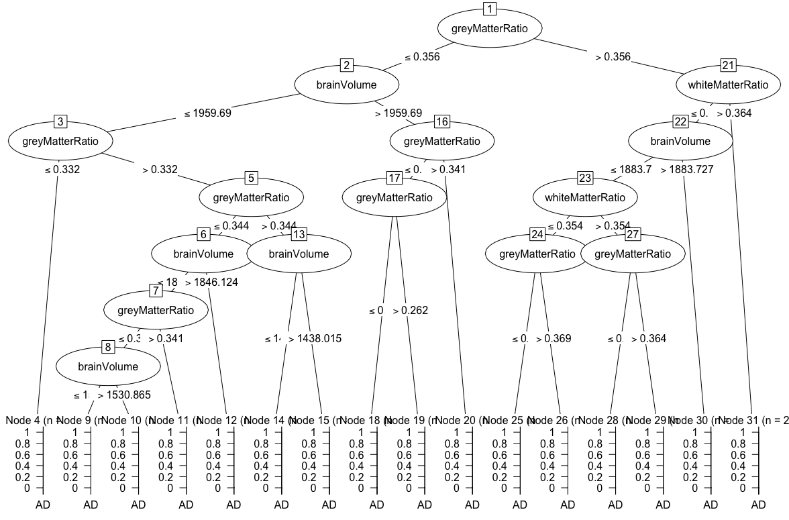

Confusion Matrix and Statistics

Reference

Prediction AD CN MCI

AD 2 0 1

CN 2 20 12

MCI 4 8 43

Overall Statistics

Accuracy : 0.7065

95% CI : (0.6024, 0.7969)

No Information Rate : 0.6087

P-Value [Acc > NIR] : 0.03299

Kappa : 0.4365

Mcnemar's Test P-Value : 0.20354

Statistics by Class:

Class: AD Class: CN Class: MCI

Sensitivity 0.25000 0.7143 0.7679

Specificity 0.98810 0.7812 0.6667

Pos Pred Value 0.66667 0.5882 0.7818

Neg Pred Value 0.93258 0.8621 0.6486

Prevalence 0.08696 0.3043 0.6087

Detection Rate 0.02174 0.2174 0.4674

Detection Prevalence 0.03261 0.3696 0.5978

Balanced Accuracy 0.61905 0.7478 0.7173

### Results of Unsupervised Learning

For experiment purposes unsupervised learning technique was used, to answer the question about whether a computer could separate a healthy brain image from an Alzheimer’s disease diagnosed one. As output of the NBClust, function suggested that optimum number of clusters is two.

*******************************************************************

* Among all indices:

* 11 proposed 2 as the best number of clusters

* 4 proposed 3 as the best number of clusters

* 5 proposed 4 as the best number of clusters

* 4 proposed 5 as the best number of clusters

***** Conclusion *****

* According to the majority rule, the best number of clusters is 2

*******************************************************************

As the output of the NBClust function number of clusters were suggested to be 2 by 11 criteria out of 26, as to the majority rule best number of clusters were chosen to be 2.

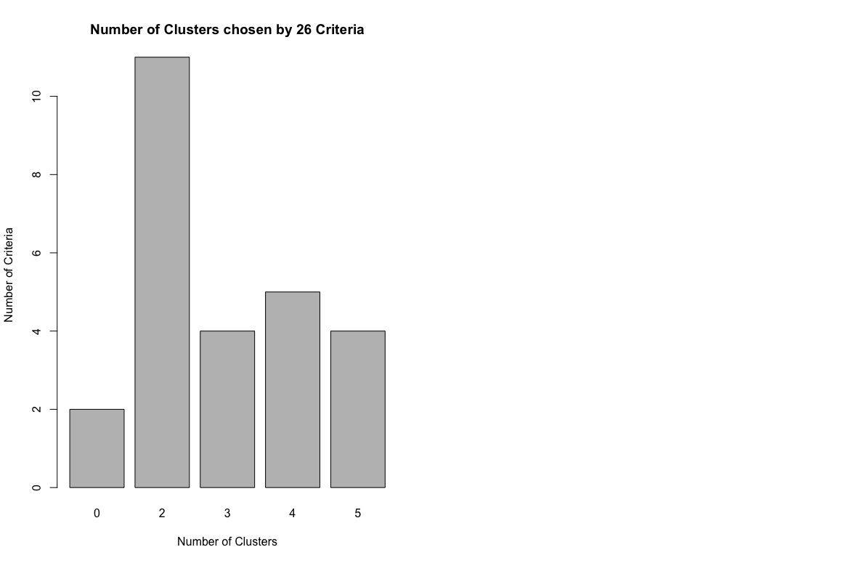

**Figure 6:** Barchart of the output of the NBClust function.

X-axis indicates the number of clusters suggested be the numerous criteria and Y-axis shows the number of criterion.

After determining the suggested cluster number dataset split up to 2 clusters since NbClust algorithm suggested such. KMeans algorithm was used for clustering and output of the algorithm was visualized in Figure 6.

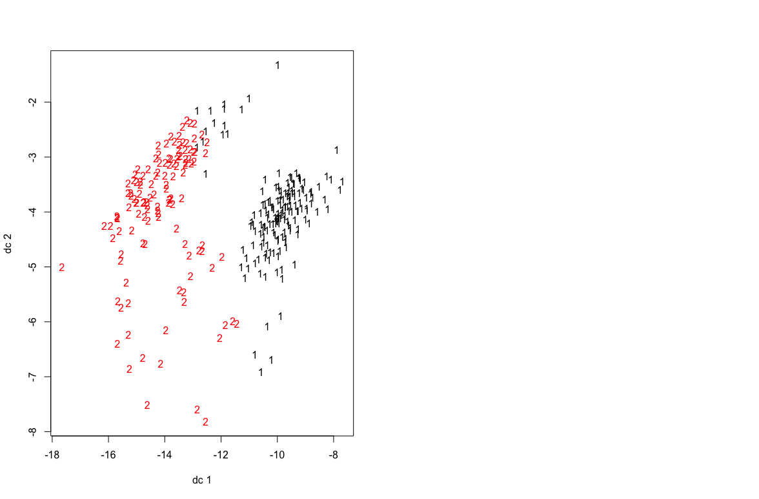

**Figure 7:** Visualization of how kmeans split the whole dataset into two clusters.

In the graph 1’s are indicating the first cluster and 2’s are the second one.

To assess the accuracy of the kmeans algorithm a confuse table was created and partitions, which the number of all pairs of data points are either put into the same cluster or different clusters, were tested using RandIndex function.

1 2

AD 31 14

CN 54 42

MCI 81 70

ARI

-0.006042262

# Discussion

Patient Data --- 50 , 50 no gender bias?

In this part, effectiveness of Spherical Brain Mapping on texture measures on prediction of MCI patients’ conversion rate to AD (Martinez-Murcia et al., 2016). Since MR images are used frequently on diagnosis of AD by inspecting the decrease of the grey matter and white matter, yet decay is mainly been seen in the grey matter tissue (Baron et al., 2001, Misra et al., 2009).

Reasons to use k-means: 1. Select as many points as the number of desired clusters to create initial centers. 2. Each observation is then associated with the nearest center to create temporary clusters. 3. The gravity centers of each temporary cluster are calculated and these become the new cluster centers. 4. Each observation is reallocated to the cluster that has the closest center. 5. This procedure is iterated until convergence.

# Conclusion

# References

BACHMAN, D. L., WOLF, P. A., LINN, R. T., KNOEFEL, J. E., COBB, J. L., BELANGER, A. J., WHITE, L. R. & D'AGOSTINO, R. B. 1993. Incidence of dementia and probable Alzheimer's disease in a general population: the Framingham Study. *Neurology,* 43**,** 515-9.

BAMFORD, C., ECCLES, M., STEEN, N. & ROBINSON, L. 2007. Can primary care record review facilitate earlier diagnosis of dementia? *Fam Pract,* 24**,** 108-16.

BARON, J. C., CHETELAT, G., DESGRANGES, B., PERCHEY, G., LANDEAU, B., DE LA SAYETTE, V. & EUSTACHE, F. 2001. In vivo mapping of gray matter loss with voxel-based morphometry in mild Alzheimer's disease. *Neuroimage,* 14**,** 298-309.

BERMEJO-PAREJA, F., BENITO-LEON, J., VEGA, S., MEDRANO, M. J., ROMAN, G. C. & NEUROLOGICAL DISORDERS IN CENTRAL SPAIN STUDY, G. 2008. Incidence and subtypes of dementia in three elderly populations of central Spain. *J Neurol Sci,* 264**,** 63-72.

BERRIOS, G. E. 1987. Dementia during the seventeenth and eighteenth centuries: a conceptual history. *Psychol Med,* 17**,** 829-37.

BROOKMEYER, R., JOHNSON, E., ZIEGLER-GRAHAM, K. & ARRIGHI, H. M. 2007. Forecasting the global burden of Alzheimer's disease. *Alzheimers Dement,* 3**,** 186-91.

BUDSON, A. E., SOLOMON, P. R. & BUDSON, A. E. 2016. Memory loss, Alzheimer's disease, and dementia : a practical guide for clinicians.

BURNS, A. & ILIFFE, S. 2009. Dementia. *BMJ,* 338**,** b75.

COMISSION DE LA TRANSPARENCE 2012. Drugs for Alzheimer's disease: best avoided. No therapeutic advantage. *Prescrire Int,* 21**,** 150.

DUNCAN, G. W., KHOO, T. K., COLEMAN, S. Y., BRAYNE, C., YARNALL, A. J., O'BRIEN, J. T., BARKER, R. A. & BURN, D. J. 2014. The incidence of Parkinson's disease in the North-East of England. *Age Ageing,* 43**,** 257-63.

EVANS, D. A., BENNETT, D. A., WILSON, R. S., BIENIAS, J. L., MORRIS, M. C., SCHERR, P. A., HEBERT, L. E., AGGARWAL, N., BECKETT, L. A., JOGLEKAR, R., BERRY-KRAVIS, E. & SCHNEIDER, J. 2003. Incidence of Alzheimer disease in a biracial urban community: relation to apolipoprotein E allele status. *Arch Neurol,* 60**,** 185-9.

FERNANDEZ-MIRANDA, C., CANCELAS, P., DE LA CALLE, A., GOMEZ, R., MORENO, E., GOMEZ-GERIQUE, J. & DEL PALACIO, A. 1997. Changes in phenotypes of apolipoprotein E and apolipoprotein(a) in liver transplant recipients. *Clin Transplant,* 11**,** 325-7.

FRISONI, G. B., FOX, N. C., JACK, C. R., JR., SCHELTENS, P. & THOMPSON, P. M. 2010. The clinical use of structural MRI in Alzheimer disease. *Nat Rev Neurol,* 6**,** 67-77.

GOLDE, T. E., ECKMAN, C. B. & YOUNKIN, S. G. 2000. Biochemical detection of Abeta isoforms: implications for pathogenesis, diagnosis, and treatment of Alzheimer's disease. *Biochim Biophys Acta,* 1502**,** 172-87.

ILIFFE, S., ROBINSON, L., BRAYNE, C., GOODMAN, C., RAIT, G., MANTHORPE, J., ASHLEY, P. & DE, N. P. C. C. S. G. 2009. Primary care and dementia: 1. diagnosis, screening and disclosure. *Int J Geriatr Psychiatry,* 24**,** 895-901.

KNOPMAN, D. S., DEKOSKY, S. T., CUMMINGS, J. L., CHUI, H., COREY-BLOOM, J., RELKIN, N., SMALL, G. W., MILLER, B. & STEVENS, J. C. 2001. Practice parameter: diagnosis of dementia (an evidence-based review). Report of the Quality Standards Subcommittee of the American Academy of Neurology. *Neurology,* 56**,** 1143-53.

KOSTOPOULOU, O., DELANEY, B. C. & MUNRO, C. W. 2008. Diagnostic difficulty and error in primary care--a systematic review. *Fam Pract,* 25**,** 400-13.

MARTINEZ-MURCIA, F. J., GORRIZ, J. M., RAMIREZ, J., ORTIZ, A. & FOR THE ALZHEIMER'S DISEASE NEUROIMAGING, I. 2016. A Spherical Brain Mapping of MR Images for the Detection of Alzheimer's Disease. *Curr Alzheimer Res,* 13**,** 575-88.

MASTERS, C. L., BATEMAN, R., BLENNOW, K., ROWE, C. C., SPERLING, R. A. & CUMMINGS, J. L. 2015a. Alzheimer's disease. *Nat Rev Dis Primers,* 1**,** 15056.

MASTERS, M. C., MORRIS, J. C. & ROE, C. M. 2015b. "Noncognitive" symptoms of early Alzheimer disease: a longitudinal analysis. *Neurology,* 84**,** 617-22.

MATHIS, C. A., BACSKAI, B. J., KAJDASZ, S. T., MCLELLAN, M. E., FROSCH, M. P., HYMAN, B. T., HOLT, D. P., WANG, Y., HUANG, G. F., DEBNATH, M. L. & KLUNK, W. E. 2002. A lipophilic thioflavin-T derivative for positron emission tomography (PET) imaging of amyloid in brain. *Bioorg Med Chem Lett,* 12**,** 295-8.

MISRA, C., FAN, Y. & DAVATZIKOS, C. 2009. Baseline and longitudinal patterns of brain atrophy in MCI patients, and their use in prediction of short-term conversion to AD: results from ADNI. *Neuroimage,* 44**,** 1415-22.

PINI, L., PIEVANI, M., BOCCHETTA, M., ALTOMARE, D., BOSCO, P., CAVEDO, E., GALLUZZI, S., MARIZZONI, M. & FRISONI, G. B. 2016. Brain atrophy in Alzheimer's Disease and aging. *Ageing Res Rev,* 30**,** 25-48.

POPESCU, V., BATTAGLINI, M., HOOGSTRATE, W. S., VERFAILLIE, S. C., SLUIMER, I. C., VAN SCHIJNDEL, R. A., VAN DIJK, B. W., COVER, K. S., KNOL, D. L., JENKINSON, M., BARKHOF, F., DE STEFANO, N., VRENKEN, H. & GROUP, M. S. 2012. Optimizing parameter choice for FSL-Brain Extraction Tool (BET) on 3D T1 images in multiple sclerosis. *Neuroimage,* 61**,** 1484-94.

PRINCE, M., ALBANESE, E., GUERCHET, M. & PRINA, M. 2014. Dementia and risk reduction: an analysis of protective and modifiable risk factors. . *Alzheimer’s Disease International.*

ROWE, C. C., BOURGEAT, P., ELLIS, K. A., BROWN, B., LIM, Y. Y., MULLIGAN, R., JONES, G., MARUFF, P., WOODWARD, M., PRICE, R., ROBINS, P., TOCHON-DANGUY, H., O'KEEFE, G., PIKE, K. E., YATES, P., SZOEKE, C., SALVADO, O., MACAULAY, S. L., O'MEARA, T., HEAD, R., COBIAC, L., SAVAGE, G., MARTINS, R., MASTERS, C. L., AMES, D. & VILLEMAGNE, V. L. 2013. Predicting Alzheimer disease with beta-amyloid imaging: results from the Australian imaging, biomarkers, and lifestyle study of ageing. *Ann Neurol,* 74**,** 905-13.

SALLOWAY, S., SPERLING, R. & BRASHEAR, H. R. 2014. Phase 3 trials of solanezumab and bapineuzumab for Alzheimer's disease. *N Engl J Med,* 370**,** 1460.

SELKOE, D. J. 2001. Alzheimer's disease: genes, proteins, and therapy. *Physiol Rev,* 81**,** 741-66.

SHI, F., LIU, B., ZHOU, Y., YU, C. & JIANG, T. 2009. Hippocampal volume and asymmetry in mild cognitive impairment and Alzheimer's disease: Meta-analyses of MRI studies. *Hippocampus,* 19**,** 1055-64.

SLUIMER, J. D., VAN DER FLIER, W. M., KARAS, G. B., FOX, N. C., SCHELTENS, P., BARKHOF, F. & VRENKEN, H. 2008. Whole-brain atrophy rate and cognitive decline: longitudinal MR study of memory clinic patients. *Radiology,* 248**,** 590-8.

VILLEMAGNE, V. L., BURNHAM, S., BOURGEAT, P., BROWN, B., ELLIS, K. A., SALVADO, O., SZOEKE, C., MACAULAY, S. L., MARTINS, R., MARUFF, P., AMES, D., ROWE, C. C., MASTERS, C. L., AUSTRALIAN IMAGING, B. & LIFESTYLE RESEARCH, G. 2013. Amyloid beta deposition, neurodegeneration, and cognitive decline in sporadic Alzheimer's disease: a prospective cohort study. *Lancet Neurol,* 12**,** 357-67.

ZACCAI, J., INCE, P. & BRAYNE, C. 2006. Population-based neuropathological studies of dementia: design, methods and areas of investigation--a systematic review. *BMC Neurol,* 6**,** 2.